Model Assessment-Based Pest Management (APM) Contract Language for US HUD Housing Facilities
Scope of Work- German cockroach elimination: The Contractor shall provide all labor, materials, insurance, bonds, transportation, etc. to provide pest control services described below (green text indicates notes to procurement officers)

General requirements: (you define all attributes of a “responsible contractor”, including the number of technicians you want on the property, what they wear, time spent in each unit, etc.)

The responsible contractor agrees to provide 4 technicians on each service day to deliver APM for German cockroach control in each of the public housing units. All technicians will wear pink shirts so that they can be identified at a distance.

In units that are determined to be “heavily” infested with German cockroaches, the technician will spend a minimum of 15 minutes treating each unit. In units that are determined to have “medium” infestations, the technician will treat for a minimum of 10 minutes. In units that are determine to have low level infestations, the technician will treat for a minimum of 5 minutes as determined by assessment. Treatment includes photographing the monitors, bait application in wax paper “tacos” (Figure 1), placement of “bait tacos”.

Contactor’s personnel- Pest Control Contractors will screen and employ only qualified personnel (pesticide applicators that are either Certified or Registered Technicians within the State of…..) who will be skilled in the performance of their duties as directed by the contact language. The Contractor agrees to immediately remove any employee the HA determines to be unacceptable in the performance of their duties.

All services shall be performed by certified or registered technicians who are qualified through the Department of Agriculture or state lead agency on the specific services requested and are directly employed and supervised by the Contractor. Evidence of qualifications shall be made available to HA at the initiation of the contract.

Specific requirements:

The Contractor shall furnish all labor, tools, materials, and equipment necessary to accomplish the full elimination of German cockroaches (and other domestic or peridomestic cockroaches) in all apartment units.

Lot 1 Cockroach Assessment:
- German cockroach Assessment: The assessment portion of this contract will be conducted on or about September 1st so that all services for German cockroach elimination can begin at the end of September. This timing is essential due to the fact that German cockroach elimination will be easier to achieve during the fall and winter months when these pests are in a natural population decline.

- The assessment will consist of the contractor placing (at least) three sticky trap (Lo-Line style ONLY!) monitors in consistent locations within each apartment unit. The monitors will be labelled with the apartment unit number, and the placement location- A, B, or C. Trap A will be placed on the sink counter along the wall. Trap B will be placed below the sink (in the cabinet where the bottom and side of the cabinet come together). Trap C will be placed on the floor behind the toilet, against the wall (Figure 1). Note that all traps will be sitting on a horizontal surface but placed against a vertical surface.

- Sticky trap monitors will be left in place overnight only, and collected the next day, photographed, and the number of German cockroaches determined (in all three traps; Figure 2). Based on the trap catch numbers, the apartment will be categorized as having a “heavy”, “medium” or “low” level infestation.

- Infestation levels will be categorized as follows: In all three monitors: more than 500 cockroaches = “Heavy Infestation”; 100-500 = “Medium Infestation”; 1-100 = “Low Infestation”

- The Contractor shall provide a report to the Agency Representative identifying the top thirty-three (33) percent of the most heavily infested units; the 33% medium level infestation; and the 33% low level infestations. There may be some overlap within these groups but the goal is to start with the most infested units first, then move on to the medium and low before the beginning of the following summer (so 3 treatment groups). The report (for managers) will include the site and/or development name, the total number of units, the number and specific addresses of high level units, the number and specific addresses of medium units, and the number and specific addresses of units with low level infestations. In addition, a photograph of the labelled traps will be provided to the management.

Note that: In an ideal world, we would want to service every unit every month (monitoring and/or baiting). However, the cost would quickly get prohibitive for housing authorities with large numbers of units (say 4000). Also, very few contractors would have the manpower needed to service so many units. Thus, we divide the HA units into thirds, servicing the most infested units first, in September, October, and November. Then the technicians move on to the medium infestation levels in December, January, and February. The low- level infestations are then treated in March, April, and May. So 33% of the units are being treated at any one time for 3 months at a time. This cuts costs and manpower requirements. All units will be monitored again during the summer months and high/medium level infestations will be addressed during June, July, and August. The assessment process will be repeated the following September and units will be treated again as described above EXCEPT those that have no trap catch the following September will be put on a quarterly treatment schedule. Thus lowering the price.

Lot 2- Cockroach Treatment:

Residents will not be asked to clean or empty their cupboards prior to treatment. This is to avoid any disturbance of German cockroach populations (and to make the contractor 100% responsible for the success of the APM program).

After the assessment is completed, the Contractor shall treat the top 33% (heavy infestations) of apartment units with cockroach bait twice within a 30-day period, at two (2) week intervals. Treatment every two weeks will continue for three months (one quarter). All baits, in the required amounts, will be applied into open but folded wax paper squares (Cut-Rite Wax paper Brand only; Figure 3) on site (Figure 4). These “bait tacos” will then be placed in locations where cockroach activity is evident or where the resident indicates they have seen German cockroaches (Figure 6).

HEAVY- The Contractor shall use 30 grams of bait per treatment (Figure 5) 60 g per month) of one of the following cockroach bait formulations: Vendetta (MGK), Max Force Magnum (Bayer), or Advion (Syngenta). Bait formulations will be alternated each month. No other treatment will be applied in addition to the baits. Monitoring (24 hour) will be conducted in these units at the end of each of the three months (3 times) to determine treatment efficacy. Monitoring records will be provided to the Agency Representative.

- At the end of the third treatment month the Contractor will assess trap catch for the top 33% (heavy infestation) and provide additional bait treatment if necessary. All dead cockroaches will be removed by vacuuming prior the final treatment being applied. Those apartment units that need additional treatment will be added to the medium infestation schedule described below.

- MEDIUM-Utilizing the same methodology as applied in the heavily infested units, the Contractor shall begin baiting those units that have medium infestations for the subsequent three months December, January and February). For the medium units, 15-30 grams of bait will be applied twice a month depending on trap catch. The contractor will alternate bait formulations each month. Monitoring will be conducted at the end of each month to assess the infestation. Those that need additional treatment after 3 months will be added to the light infestation schedule described below.

- LOW-Utilizing the same methodology as described above, the Contractor shall focus on light infestations. Lightly infested units will receive 7.5 to 15 grams of bait in each unit once a month during March, April and May (costs should now decrease due to the once a month application). Those units that have no cockroaches will be monitored only. At this point (third quarter) it will be expected that those units previously categorized as heavily infested, or that had medium infestations should now be in the light infestation category or have no cockroaches. Light infestations will be monitored at the end of each month to determine population reductions. See below.

- ALL UNITS will be monitored again in June so that population assessments can be made. Those units that have 0 -10 cockroaches total in all three monitors, can then be moved to a quarterly treatment schedule. Those units that have >10 cockroaches in all three monitors will continue on a monthly treatment schedule and baited according to trap catch numbers over the summer months (alternating bait products every 90 days). Multiple research studies have determined that cockroach populations will be at low levels or eliminated after this intensive treatment, with rare exception.

- The contractor must meet with the management representative at the end of each contract year (August) to discuss unit trap catch numbers (treatment efficacy and bait quantity applied in each unit). Decisions will be made as to which units can be moved to a quarterly treatment schedule for the following year. It is expected that a “responsible bidder” will be able to eliminate German cockroach infestations in more than half of the contracted apartment units the first year.

- Monitoring over the second year will determine which units can be moved to a quarterly treatment schedule, and to identify and prevent new populations that may develop into heavy infestations during the summer months.
All tenant generated work orders will be monitored overnight to determine infestation level. The Contractor shall utilize lo-line style sticky traps and apply the appropriate amount of bait (tacos) based on trap catch.
Note that while the APM German cockroach elimination process may be more expensive the first year than in previous years, the goal is German cockroach elimination. Once the German cockroaches are eliminated, the costs should decrease with the re-use of empty monitors, reduction in bait quantity, and the reduction in technician time needed. Also consider that if there are currently heavy infestations within your facilities, and you are paying for German cockroach control, what are you getting for your money?

Figure 1-Lo-Line style cockroach monitor in position “C”, behind the toilet
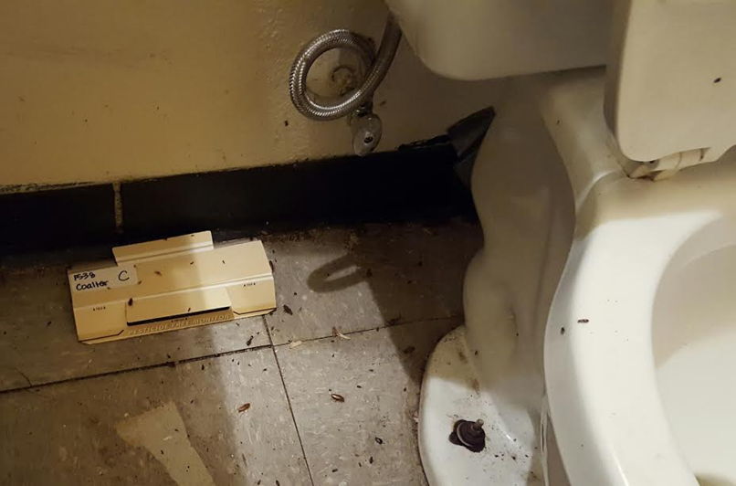

Figure 2-Photograph of labelled monitors showing overnigh trap catch
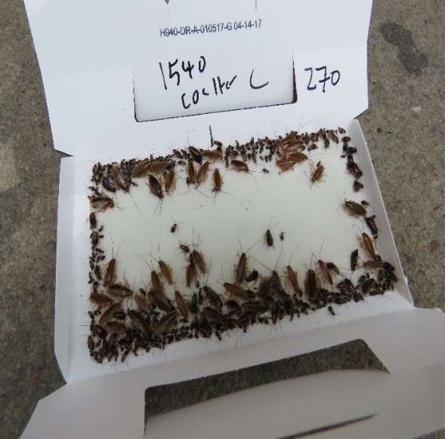
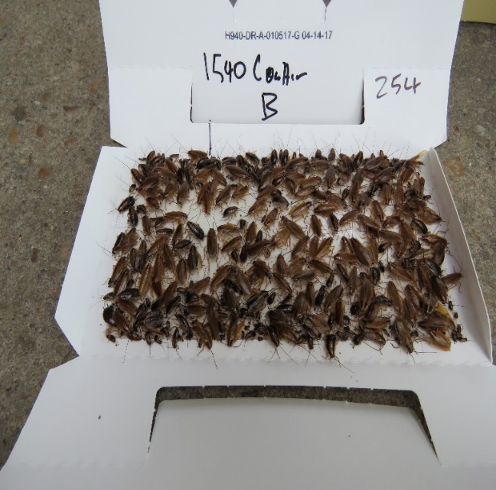

Figure 3-The only wax paper brand to be used for “Bait Tacos”
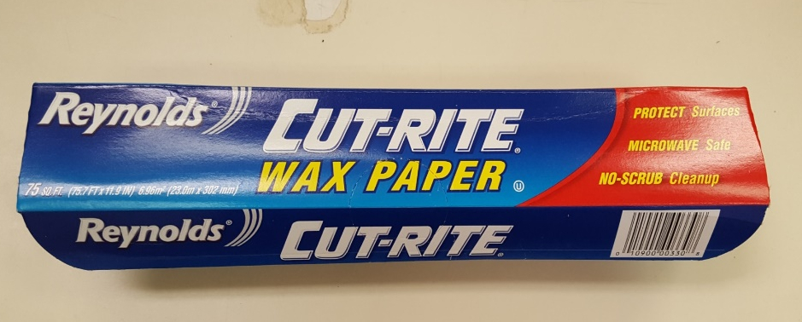

Figure 4-Applying bait to wax paper squares folded down diagonal
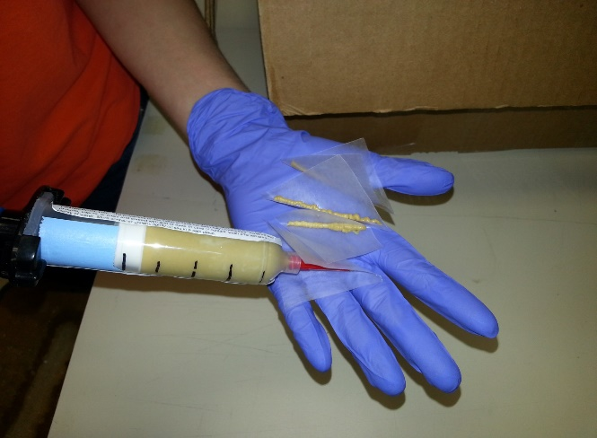

Figure 5-15g of bait tacos
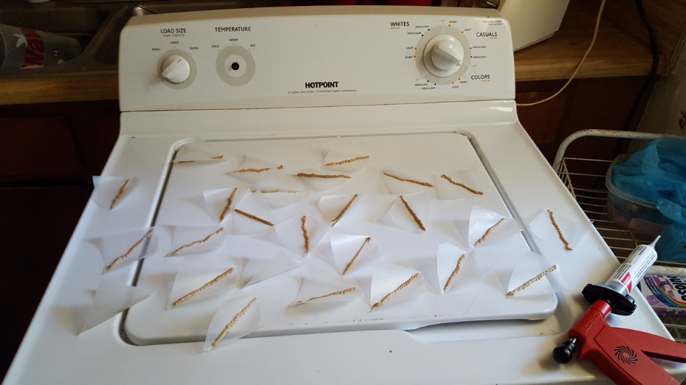

Figure 6-Placement of bait tacos in locations of German cockroach activity
