[PEST CONTROL COMPANY] will be entering your unit on the date shown above to inspect for pests in every room of your home. If they find pests, they will take steps to eliminate the problem. This service does not include the use of smelly sprays or foggers.

It is necessary for you to prepare properly before the technician arrives so that he or she can access all pest hiding spots.

Routine Pest Control Preparation Instructions
Before the inspection,
- Take items out of:
  - Kitchen cabinets where you’ve seen pests and
  - Cabinets below sinks.
- Take items off of:
  - The stove,
  - The refrigerator(s),
  - The microwave.
- Clean as if you were having a housekeeping inspection—throw away all unnecessary cardboard boxes, paper bags, and boxed or expired food products. Organize and clean your home.
- If you have seen or heard mice:
  - Open and empty all closets and storage areas.
  - Show the PMP where the mice are or leave a note.

It is not necessary to be home during the visit. If you do not plan to be home during the treatment and have concerns, leave a note on your door or fill in the bottom of this notice and leave it on your kitchen counter. If you have any questions, call the main office: [OFFICE NUMBER]

After the visit
It is extremely important that pests do not find food during the days following the treatment. Make sure no food or trash is left out. Clean up any dead pests, especially cockroaches. Eggs will hatch from dead cockroaches and re-infest your home. Both live and dead cockroaches can trigger asthma.

Your management company has implemented an IPM program with [PEST CONTROL COMPANY]. Our residential lease requires your cooperation—your part in pest control is important and appreciated.
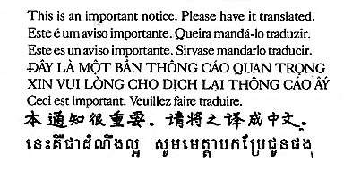
Notes for the pest management professional:

